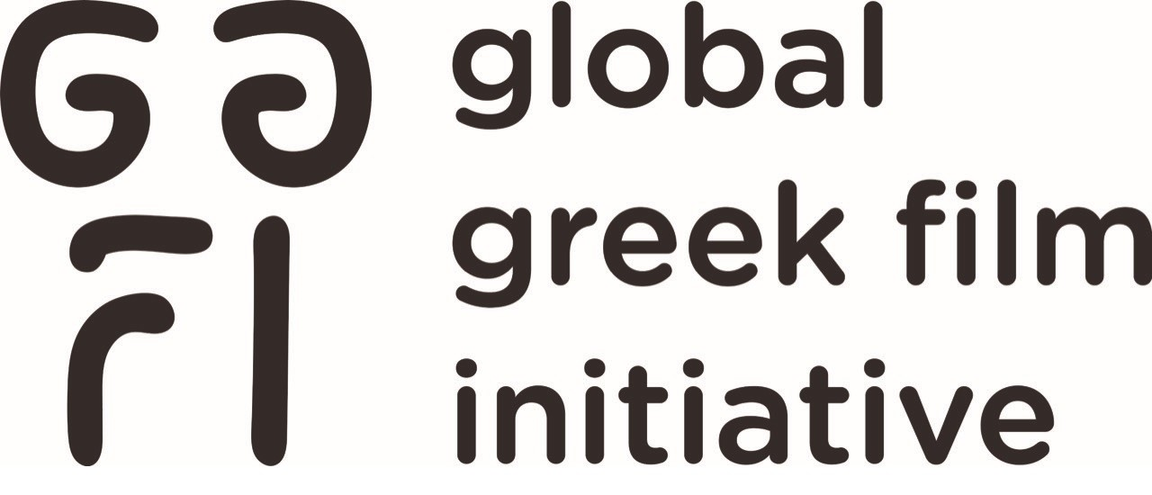

Los Angeles Greek Film Festival Launches
FOREVER LAGFF Campaign
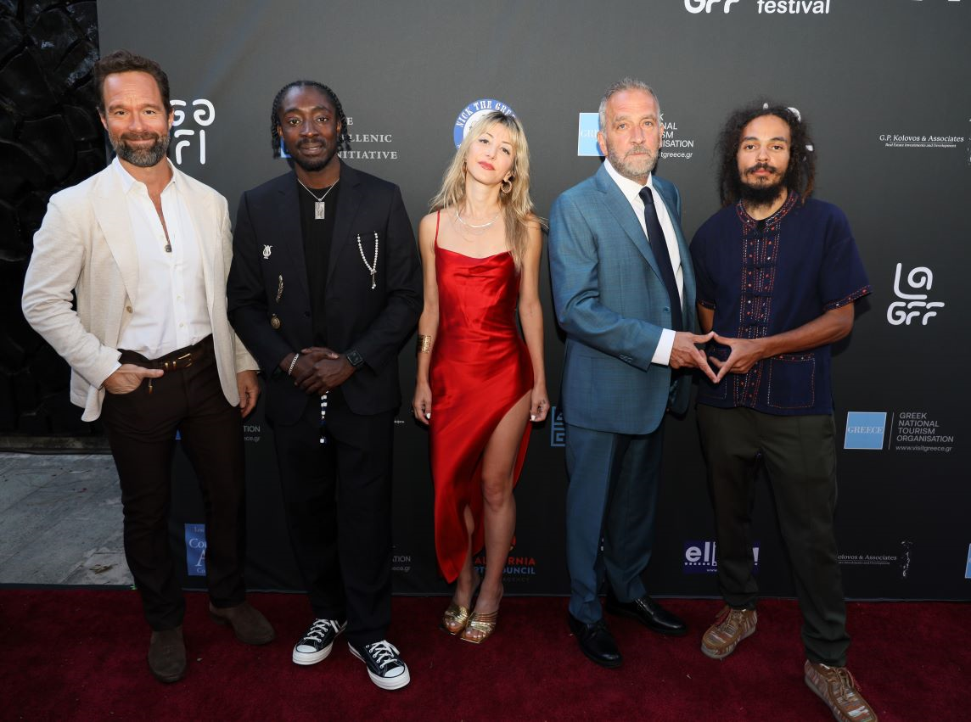

LOS ANGELES, CA - (September 5, 2023) –Los Angeles Greek Film Festival (LAGFF) has launched a fundraising campaign to raise a permanent endowment.

Over the past year, LAGFF has expanded its scope to national and international levels through the Global Greek Film Initiative, with the intention to cast a wider net of bridging possibilities between Greek filmmakers and film industry, Hollywood and the American entertainment industry, as well as the Hellenic Diaspora in the U.S. and the world.
The organization’s staple event, the Los Angeles Greek Film Festival, has grown and expanded out of the ashes of the pandemic and other challenges. In 2023, its 17th edition outshone past festivals. More than ever, connecting paths among Greek, American, international artists and local and virtual audiences were firmly established.
After a rapid period of growth, the organization is now seeking to match a challenge posed by a benefactor who prefers to remain anonymous. This benefactor has pledged to match up to $500,000 dollar-for-dollar, to establish a one-million-dollar endowment that will be invested to secure the future of LAGFF for generations to come. A private fundraiser event is slated for December and the “Forever LAGFF” campaign will remain active through 2023.
LAGFF, a nonprofit 501c3 charity organization with the mission to promote Greek film and media arts and create connecting pathways between Greece, America and the world, is seeking angel donors who would like to participate in this major effort to secure the future of an organization that contributes greatly to an elevated international awareness of Greek arts & culture.
All donations are tax deductible. Angel donors who give $50,000 or more will be permanently recognized on the organization’s media and infrastructure, as well as enjoy other acknowledgements.
LAGFF stands in solidarity with the strikers and acknowledges that this is a challenging time for industry writers and actors. However, the FOREVER LAGFF campaign is geared toward donors who recognize the timeless value of the arts & culture.
For more information and for customized donor packages, please contact Co-Founder Ersi Danou at info@lagreekfilmfestival.org. Follow @lagff and @globalgreekfilm on Facebook and Instagram and sign up for the newsletter at www.lagff.org.
"Our commitment to keeping LAGFF strong reaches into the future. We are setting the stage for continued excellence among our global Greek community of filmmakers." -Alex Kalognomos
Aris Katopodis -
Ersi Danou: For the last 17 years we have done a lot to change the cultural climate of the Hellenic Diaspora in the US and to help Greek filmmakers promote their careers and their works. It is time that we take care of our organization so that our efforts bear fruit for the generations to come.
LAGFF has grown to be a world class festival and a model for festivals worldwide due to the tremendous support from the community. At the core of what we do is community. With more, we can do more. We hope to preserve LAGFF's legacy and continue to grow this amazing festival for years to come." - LAGFF Board Member, GGFI Co-Founder, Producer & Screenwriter
Katerina Frederickson -

ABOUT: LAGFF is a nonprofit organization that focuses its attention to bringing films and filmmakers from Greece, Cyprus, and the rest of the world to the United States. LAGFF has screened over 580 films and hosted over 530 filmmakers supporting their films - www.lagff.org

ABOUT: Global Greek Film Initiative is strategically designed to establish an array of new annual programs to promote cultural exchange between Greece, the U.S. and the Hellenic Diaspora, service opportunities for economic growth within Greece and to be the North American hub and global one-stop collective for Greek film programs and initiatives.
Above Photo by Steve Sasaki (from left) actor Chris Diamantopoulos, rapper Black Morris, actress Zina Wilde, novelist/screenwriter/showrunner/producer George Pelecanos and writer/director Nick Pelecanos on Opening Night of the 17th LAGFF, June 3, 2023.
Media Contact: Melinda Manos, 424-777-0548 or melinda@manospr.com

