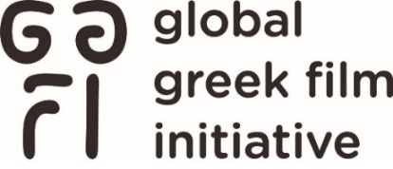
The Global Greek Film Initiative Hosts Inaugural Benefit Event
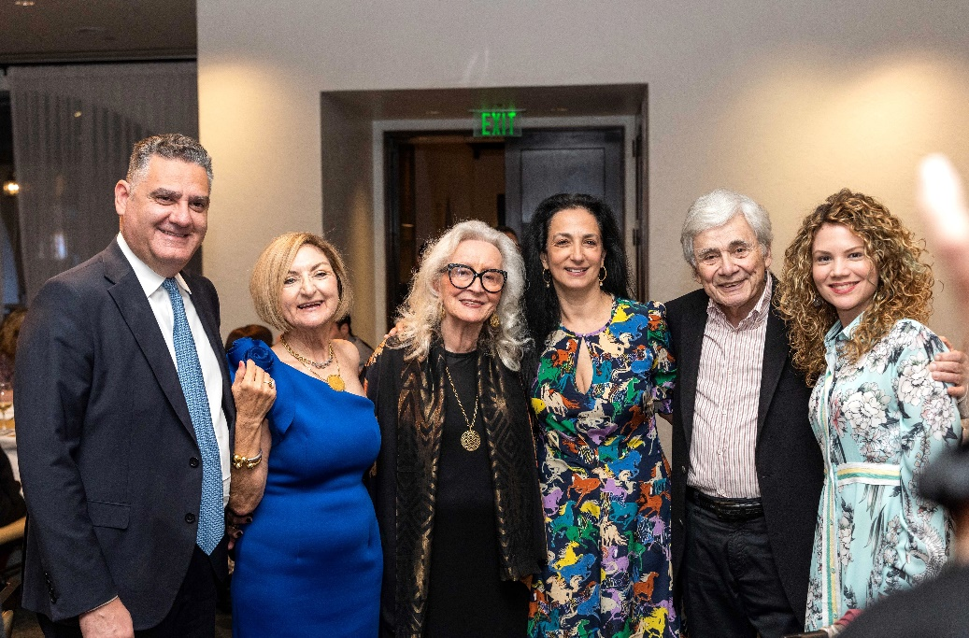
LOS ANGELES, CA – (May 10, 2023) - On Thursday, May 4th over 100 guests attended the Global Greek Film Initiative (GGFI) Benefit Event at the Wilshire Country Club to support new and expanding programs, including the annual Los Angeles Greek Film Festival (LAGFF), and raise funds.

The evening was presented by GGFI leaders Lia Bozonelis, Ersi Danou, Aris Katopodis and Director of Development Katerina Hoyo-Frederickson, and co-hosted by GGFI Trustee Theane Evangelis and GGFI supporter Jim Kousoulas. GGFI Dignitaries attending included actress, producer, author Nia Vardalos who offered introductory remarks, former studio executive & producer Jim Gianopulos, former HBO executive and producer Kary Antholis, director and producer Will Speck, actors Christos Vasilopoulos and Zina Wilde, tech entrepreneur Marily Nika, animator Aliki Theofilopoulos, music composers George Kallis and Kostas Christides, talent agent Peter Kallinteris.
Distinguished guests included Consul General of Greece in Los Angeles Ioannis Stamatekos, Honorary Consul General of Cyprus in Los Angeles Andreas Kyprianides, Father Gary Kyriakou, longtime festival donors George & Tina Kolovos, LAGFF Board Member Alex Kalognomos, Trustee Carol Contes, and popular singer Vassy.

Guests enjoyed cocktails, dinner, and live entertainment by The Greek Rebetiko Trio founded by Dimitris Mann, featuring Taso Comandesu and Eirini Nomikou. The event was coordinated by Dena Romios / Power Muse Productions. Photos by Urbanite Media.

ABOUT: Global Greek Film Initiative is strategically designed to establish an array of new annual programs to promote cultural exchange between Greece, the US and the Hellenic Diaspora, service opportunities for employment and economic growth within Greece and be the North American hub and global one-stop collective for Greek film programs and initiatives.
ABOUT: Los Angeles Greek Film Festival is reaching its adulthood. Now in its 17th year, LAGFF is growing rapidly. We have amplified our programming over two weekends June 3-11, 2023. We are promising a full lineup with film screenings, great tribute event, expanded Discovery Days industry program, exciting Hollywood Scene and Be Seen party, the inaugural LAGFF Film Student Fellowship, and more!
MISSION: To ensure the future sustainability of the organization as well as increase our presence locally, nationally and internationally across the field of entertainment. A longtime sponsor and patron of the arts and Hellenic culture has pledged up to $500,000 as an endowment to sustain the future of our organization, provided that we match the fund. This year your support is pivotal to us in reaching this fundraising challenge. Donate and be part of our growth and our community!
To donate please visit www.lagff.org and click on the DONATE button on the upper right corner.
Photo L to R
Consul General of Greece, Athena De Busk, Tina Kolovos, Katerina Zacharia, PhD, George Kolovos, and Sonia Liza Kenterman

