**2023 Los Angeles Greek Film Festival Red Carpet Closing Night**

**\*\* Orpheus Awards & Celebration \*\***

# LOS ANGELES, CA [June 11, 2023] - The red carpet Closing Night of the 17th [Los Angeles Greek Film Festival](http://www.lagff.org) (LAGFF) on Sunday, June 11 at the Silver Screen Theatre, Pacific Design Center featured the LA Premiere of award-winning film LISTEN (Greece, 2022) **written and directed by Maria Douza. Douza and actors Efthalia Papakosta and Dimitris Kitsos were in attendance.**

# The 2023 Orpheus Award ceremony followed the screening and was emceed by AFI’s Chris Schwartz. Guests included VIPs, celebrities, dignitaries, jurors, and sponsors, along with filmmakers from Greece and Cyprus and international filmmakers of Greek descent. A lively reception catered by Nick The Greek concluded the evening.

LAGFF 2023 included films, filmmakers, Masterclasses, Workshops, events and a virtual program of screenings following the Festival. “Over the past 17 years, LAGFF has screened over 650 films and hosted over 550 filmmakers supporting their films,” Festival Director Aris Katopodis stated. “The Festival is getting bigger, stronger and bolder. Over 80 films were either screened or available on our platform. While looking outwards, LAGFF is expanding its collaborations with a host of US based and international institutions.”

LAGFF 2023 Trailer Montage - <https://www.youtube.com/watch?v=3vwBNFdlONA>

(Edited by Nasos Gatzoulis. Original music by Enter Tarot. Amaechi Titus Ottiji)

In late 2022, LAGFF launched the Global Greek Film Initiative (GGFI) designed to establish an array of new annual programs to promote cultural exchange between Greece, the US and Hellenic Diaspora, service opportunities for employment and economic growth within Greece.

***And The Winners Are..***

**Fiction Feature Film**

**Best Fiction Film**

LISTEN by Maria Douza



**Special Jury Award for Best Film**

IMAN by Corina Avramidou and Kyriakos Tofarides

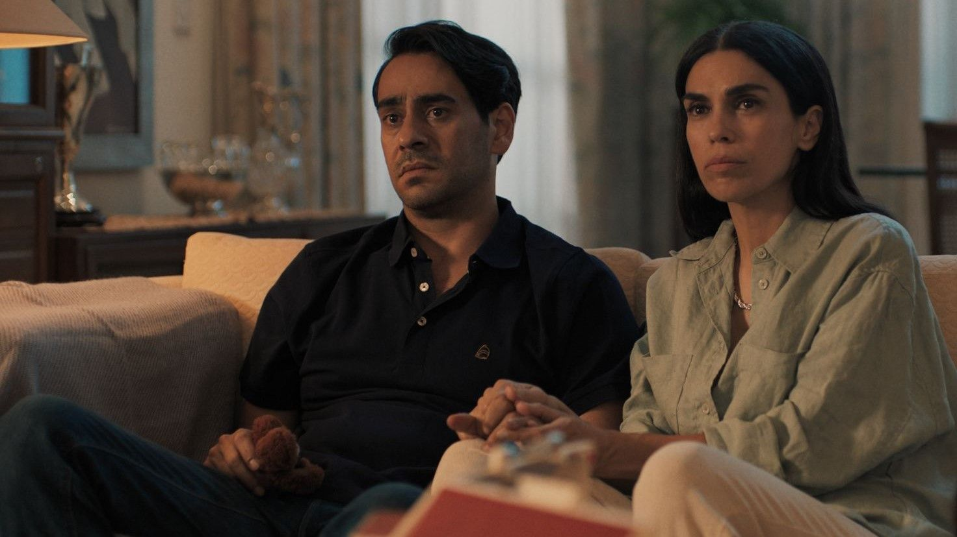

**Best Director**

Panos Koutras for DODO

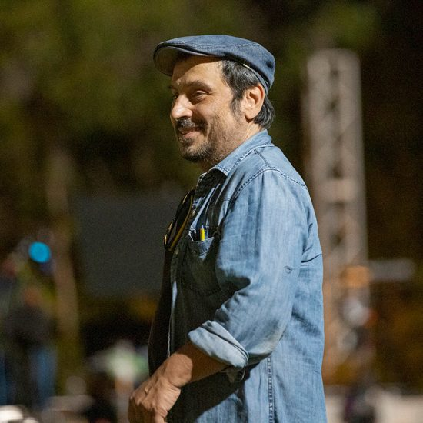

**Honorable Mention for Best Director**

Spiros Jacovides for Black Stone

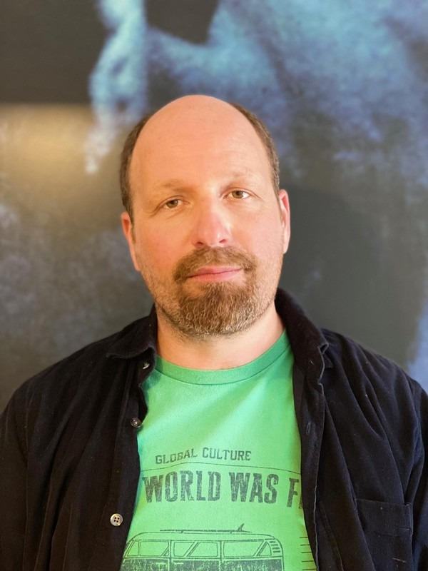

**Best Performance**

Efthalia Papacosta (Listen)



**Honorable Mention for Best Performance**

**Stephanie Atala for IMAN**



**Documentaries**

Best Documentary

The Other Half by Giorgos Moutafis – (from the **online** slate)

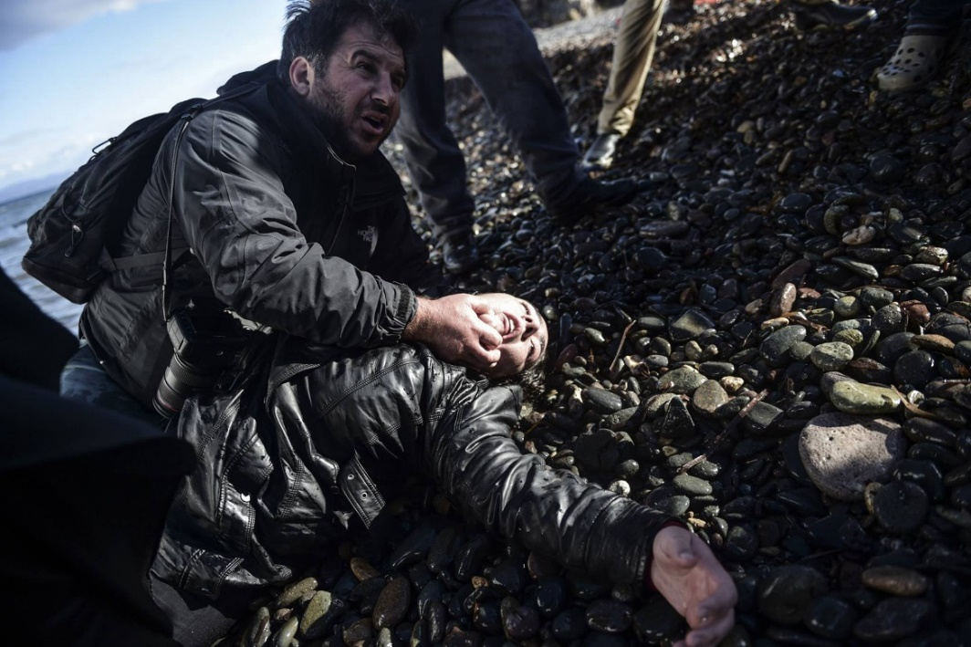

Special Jury Prize for Documentary Directing

Queen of the Deuce by Valorie Kontakos

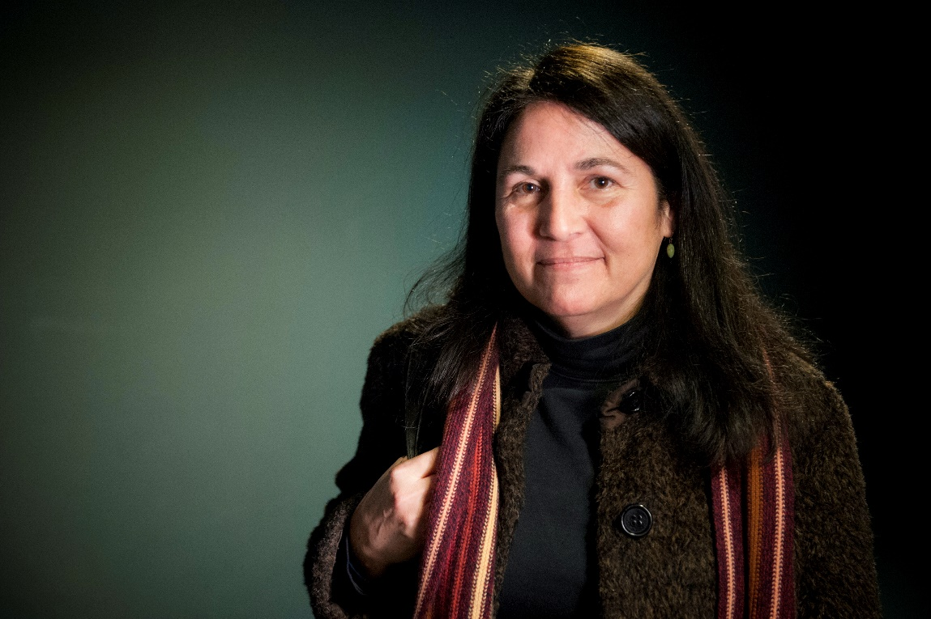

**Short Films**

Best Short

Pebble by Karina Logothetis

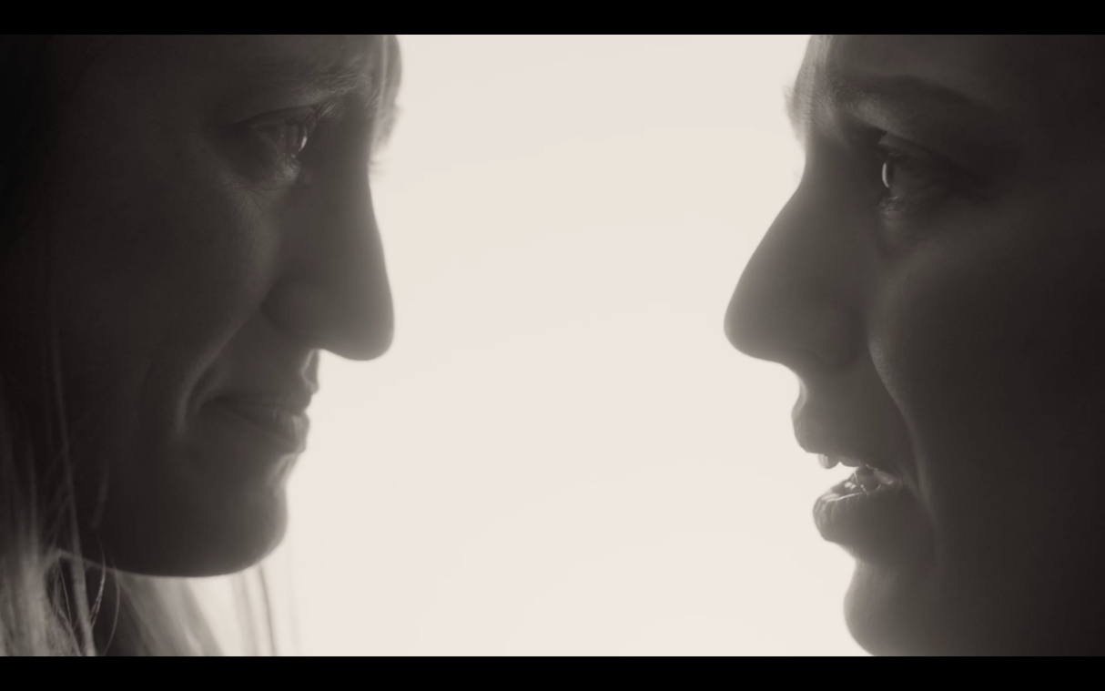

Special Jury Award

Air Hostess - 737 by Thanasis Neofotistos

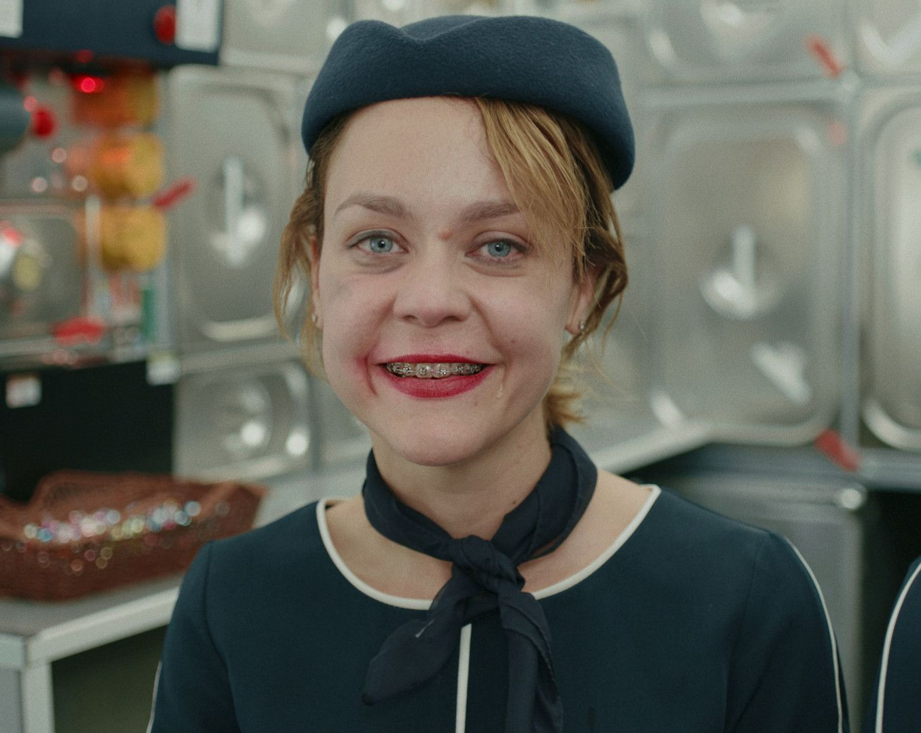

Honorable Mention

5 pm Seaside by Valentin Stejskal

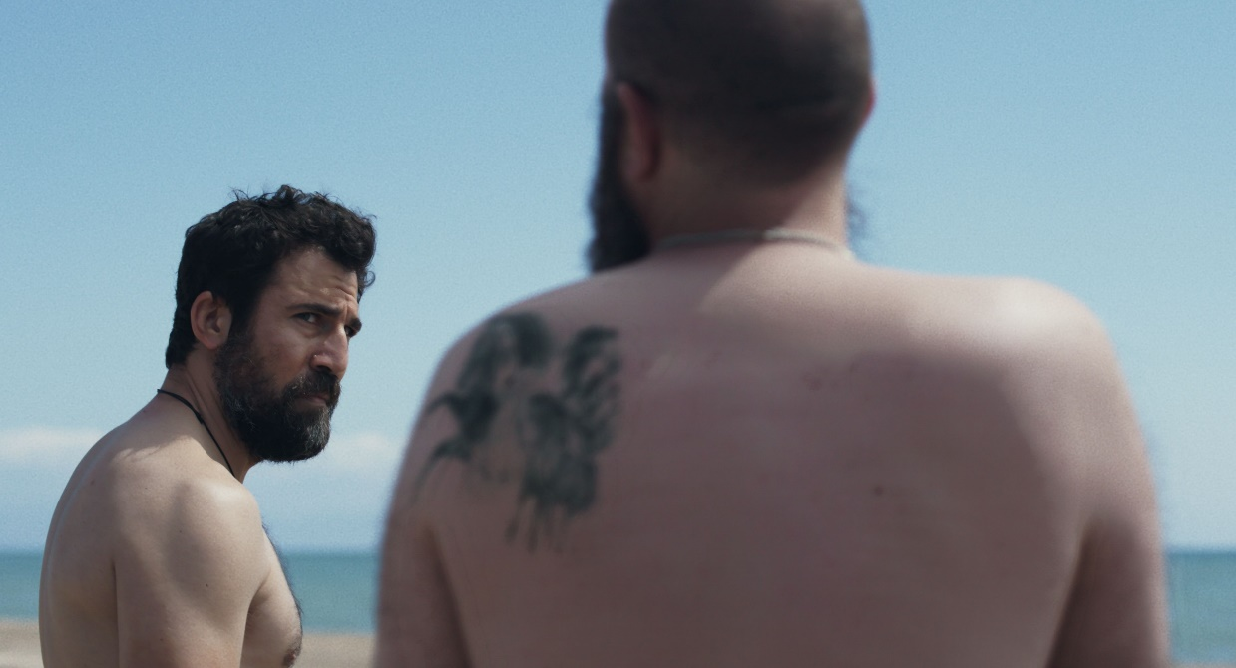

**Animation**

Best Animation

My Mother the Sea by Aspasia Kazeli

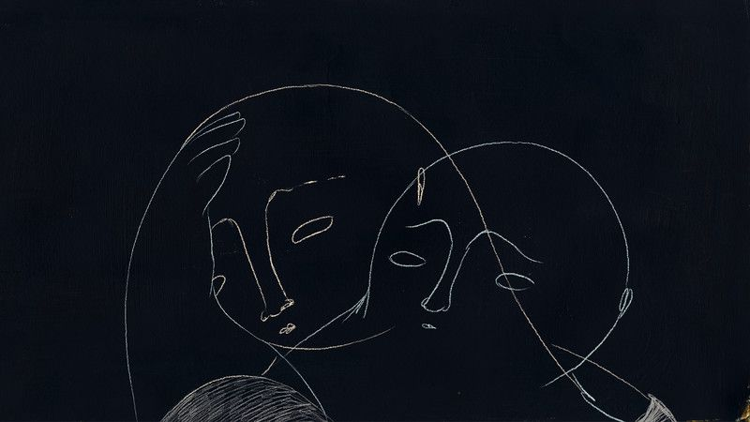

Honorable Mention

The Trojan Horace by Scott Graham



**Audience Award –**

**DOCUMENTARY FILM**

Venizelos: the Struggle for Asia Minor

**SHORT FILM**

Share For Me

**FEATURE FILM**

Black Stone

**Discovery Days,** formerly the International Project Discovery Forum (IPDF), is a Los Angeles pioneer in the promotion of international independent film development. It is the industry section of the Los Angeles Greek Film Festival. Utilizing the innumerable cinematic resources in Los Angeles, the mission is to create a bridge between two very different worlds – those of American and European independent cinema.

The 2023 Jury: Producer & Sundance’s Catalyst Program Director Giulia Caruso, Programmer-Producer Drea Clark (A VIEW OF THE WORLD FROM FIFTH AVENUE), Director Yannis Sakaridis

(AMERIKA SQUARE) and Filmmaker-Editor Nicole Otero (SLIP).

DISCOVERY DAYS Co-Founder/Director Araceli Lemos states, “The ninth edition of Discovery Days brought six unique projects that are currently in development to Los Angeles to be workshopped and presented to industry professionals here. We thank the filmmakers for trusting us to help them with their stories during this exciting and vulnerable stage. I am always amazed by how large a leap forward the filmmakers take, thanks to the support of the generous creative community that has been built around the lab throughout the years.”

**Winner:**

The jury was impressed by this film's ability to weave cultural specificity into a contemporary world, to bridge ancient stories with fresh resonance. It reminded us all of the devastating yet critical moment when we finally see our parents as imperfect beings. And yet all of these themes are inside of an adventure we all want to go on with our families. With a very clever title to boot. We are happy to grant the Discovery Days award to A Girl Named Zeus by Nikos Dayandas.

**Honorable Mention:**

We give honorable mention to a project that shows a lot of promise in its premise, perspective, and ambition. We hope this acknowledgment will encourage you to take your ideas to script, to craft an exceptional cast of characters to support all the nuance in the world you want to create. Our honorable mention is Story from A Southern Coast by Alki Politi.

IMAGES:

Discovery Days 2023 Team and Filmmakers - attached photo:

Iris Baglanea, Jeff Stockwell, Karina Logothetis, Nasos Gatzoulis, Isabella Margara, Fokion Bogris, Nikos Dayandas, Dimitris Tsakaleas, Lida Vartzioti, Araceli Lemos, Alki Politi, Joel Garber, Katerina Kiagia (Photo by Urbanite LA)

**ABOUT: LAGFF** is a 501(c)(3) nonprofit organization that focuses it’s attention to bringing films and filmmakers from Greece, Cyprus, and the rest of the world to the United States. LAGFF runs from June 3-11, 2023. For more information, visit [www.lagff.org](http://www.lagff.org)

Media Contact: Manos PR 310-272-4225