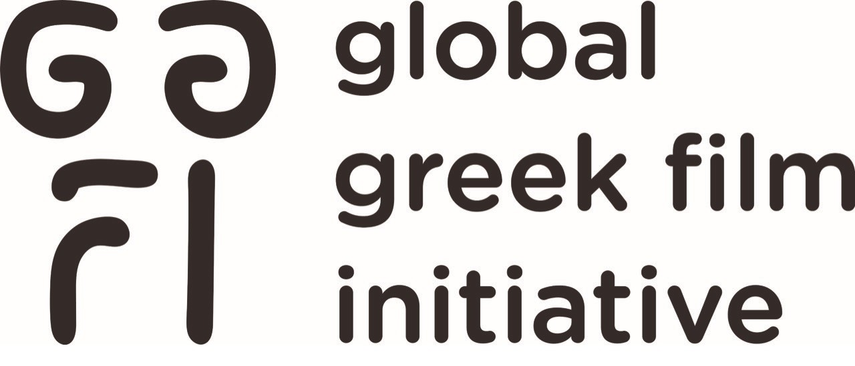
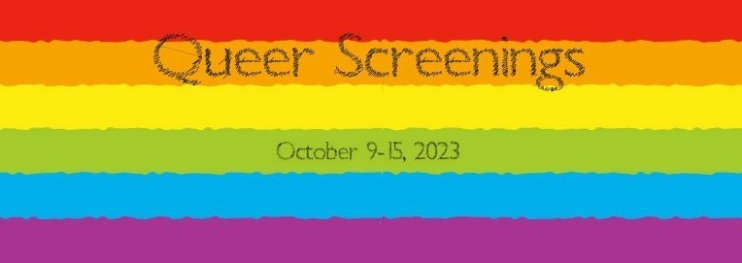

LAGFF Presents an LGBTQ Program by Greek Filmmakers
Streaming October 9-15, 2023 with Community Support from Outfest

LOS ANGELES, CA - (October 4, 2023) - The Los Angeles Greek Film Festival (LAGFF) is thrilled to present a curated collection of LGBTQ-themed works by Greek filmmakers. The 16 film LGBTQ Program is available on LAGFF’s online platform for one week from October 9-15, 2023.

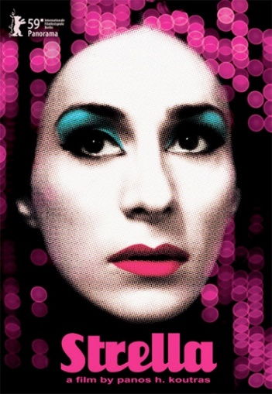
The LGBTQ themed program includes award-winning STRELLA, a landmark film in Greek Queer filmmaking history, the 2019 Cannes Palme d’Or winning short film THE DISTANCE BETWEEN US AND THE SKY, and the documentary-fiction OBSCURO BARROCO featuring masterful photography about the dizzying heights of gender and metamorphosis in Rio de Janeiro.

Virtual film screenings are free and have community support from OUTFEST.
LGBTQ Film Guide/Registration: https://queer23.eventive.org/welcome

Two In-Person LAGFF Screenings in October

- Sonia Liza Kenterman’s heart-warming feature debut, TAILOR, will be screened at St. Sophia Huffington Center in Los Angeles on Sunday, October 8. Kenterman will be in attendance for Q & A.

- A screening of the poetic, feature documentary MAUTHAUSEN directed by Panagiotis Kountouras and Aristarchos Papadaniel is slated for Sunday, October 29. The film includes Mauthausen Cantata, the masterpiece musical memorial of the martyrdom, with lyrics by Greek poet Iakovos Kambanellis, a Mauthausen concentration camp survivor, and music by Mikis Theodorakis. Both events are co-presented by St. Sophia Huffington Center.

Please consider making a tax-deductible donation by visiting www.lagff.org, and support our growth!

The 18th LAGFF is June 1-9, 2024 and film submissions are now OPEN.

ABOUT: Los Angeles Greek Film Festival (LAGFF) is a 501(c)(3) nonprofit organization (Tax ID 20-4384707) that focuses its attention to bringing films and filmmakers from Greece, Cyprus, and the rest of the world to the United States. LAGFF has screened over 800 films and hosted over 700 filmmakers supporting their films.
ABOUT: Global Greek Film Initiative (GGFI) belongs to the same nonprofit organization and is strategically designed to establish an array of new annual programs to promote cultural exchange between Greece, the U.S. and the Hellenic Diaspora, service opportunities for employment and economic growth within Greece and to be the North American hub and global one-stop collective for Greek film programs and initiatives.

