FOR IMMEDIATE RELEASE:

**Los Angeles Greek Film Festival and Global Greek Film Initiative Announce New Board Members**

LOS ANGELES, CA – (April 3, 2024) - The Los Angeles Greek Film Festival (LAGFF) announced three new board members who will help support the nonprofit festival’s work. Television Director/Producer & Showrunner **Greg Yaitanes**, TV Executive & Producer **Kary Antholis** and Marketing Executive & Academy Member **Christina Kounelias** joined the Global Greek Film Initiative (GGFI) and Los Angeles Greek Film Festival (LAGFF) Board of Directors effective January 2024.

LAGFF/GGFI Co-Founder/President Ersi Danou, Screenwriter & Producer and LAGFF Vice President Lia Bozonelis and Events Producer & LAGFF Treasurer/Secretary Alex Kalognomos are thrilled to welcome fellow Board Members of such professional caliber. “We’re excited to expand our Board at a time when Los Angeles Greek Film Festival has widened its scope of action through Global Greek Film Initiative,” said Ersi Danou. “We have worked diligently to ensure our board and leadership represents a variety of experts, and the newest board members are no exception.”

New Board members:

* **Greg Yaitanes** is a visionary, Emmy-winning director and producer known for his ability to build new worlds through technical ingenuity while preserving his refined artistic aesthetic on-screen. He currently serves as Executive Producer and Director on Apple TV+’s Presumed Innocent, the upcoming limited series from David E. Kelley, J.J. Abrams’
* Bad Robot, and Warner Bros. TV, which stars Jake Gyllenhaal.

Yaitanes served as the Co-Executive Producer of HBO’s House of the Dragon, executive produced and directed Castle Rock for J.J. Abrams and Stephen King, as well as Jordan Peele’s The Twilight Zone. He has led his team to 38 Emmy nominations and 6 wins in his 30-year career.

* **Kary Antholis** founded Crime Story Media, LLC in 2019, after retiring as President of Miniseries and Cinemax Programming at HBO. Under the Crime Story banner, Antholis served as Executive Producer on the award-winning limited series Black Bird (Apple TV+, Dennis Lehane), We Own this City (HBO, George Pelecanos, David Simon), the Emmy-nominated documentary The Slow Hustle (HBO) and the hit podcast series, Firebug and Jury Duty. In his 25 years as a creative executive at HBO, Antholis oversaw many Academy Award, Emmy, and Golden Globe-winning projects.
* **Christina Kounelias** is an innovative executive and industry thought-leader with a track record of success who was named a "Top 25 Marketing Mastermind" by The Hollywood Reporter. She was President of Worldwide Marketing at Participant, a boutique production company, the first-ever CMO of the Academy of Motion Picture Arts and Sciences and held senior posts in marketing and communications at Hollywood studios including Warner Bros., New Line and Fox. Christina was key to the success of hundreds of iconic and successful motion picture and television properties, from some of the most acclaimed filmmakers and creators.

ABOUT: Global Greek Film Initiative is strategically designed to establish an array of new annual programs to promote cultural exchange between Greece, the US and the Hellenic Diaspora, service opportunities for employment and economic growth within Greece and be the North American hub and global one-stop collective for Greek film programs and initiatives.   
  
ABOUT: Los Angeles Greek Film Festival is a 501(c)(3) nonprofit organization that focuses its attention to bringing films and filmmakers from Greece, Cyprus, and the rest of the world to the United States. The 18th LAGFF will run June 1-9, 2024. More information at [www.lagff.org](http://www.lagff.org)

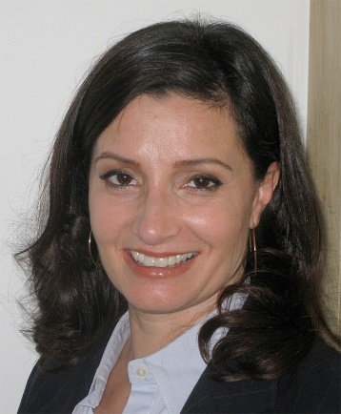 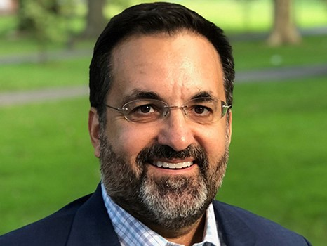

**Media Contact:**

Manos Public Relations (310) 272-4225

Melinda Manos [melinda@manospr.com](mailto:melinda@manospr.com)